Name:

Score: out of

Manjimup SHS 2015

Year 11 Mathematics Methods

Test 3

Quadratics, Functions, Transformations, Trigonometry

30

/56
Non Calculator Section (No calculator or notes, formula sheet provided)

Time: 30 minutes Marks: 30 marks

- [2,2,2 = 6 marks]

Use algebra to solve the following equations.

- (4x – 5)(x + 3) = 0 b) x² = 2x + 15 c) x³ – 4x² = 0

- [2 marks]

Find the exact values of

- cos 210º b) tan

3. [3 marks]

Consider the quadratic function f(x) = x² – 8x – 9

Find the turning point of f(x) , by using the completing the square method.

4. [3,2 = 5 marks]
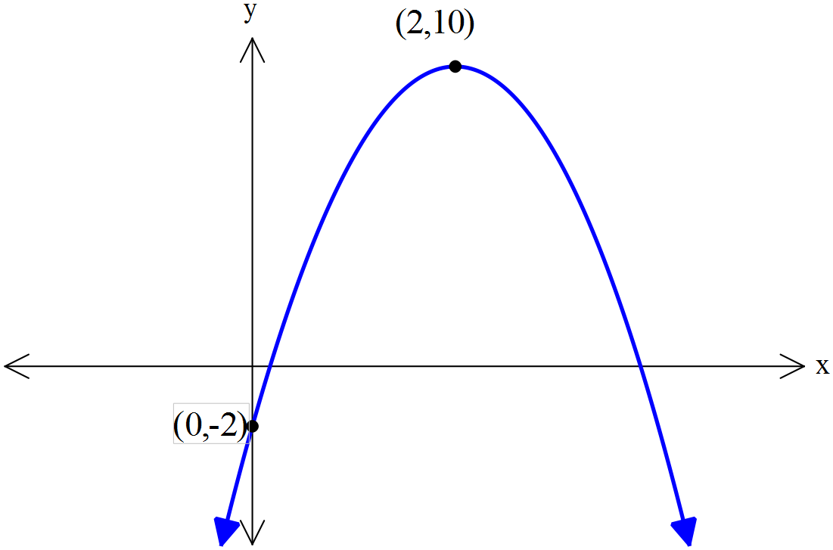
The rule for the graph shown is y = a(x – h)² + k

- Determine the values of a, h and k and
write the full rule below.

- Use algebra to change your rule into standard form; y = ax² + bx + c

5. [2 marks]

Consider the rule: y = 7 – 2 cos (.

- Find the maximum value of the function y = 7 – 2 cos (.

- Find the period of the function y = -4 tan(2πx)

6. [2 marks]
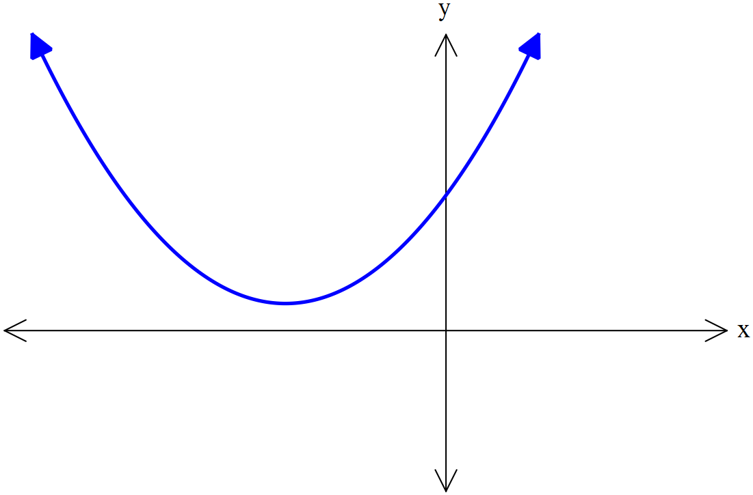

This following graph has no roots.

Select the correct rule from the list below.
Justify your answer using mathematics.

y = x² + 4x + 3 y = x² + 4x + 4 y = x² + 4x + 5

7. [3 marks]

Sketch the cubic y = 2(x + 3)(x – 2)² indicating all roots and y-intercepts.
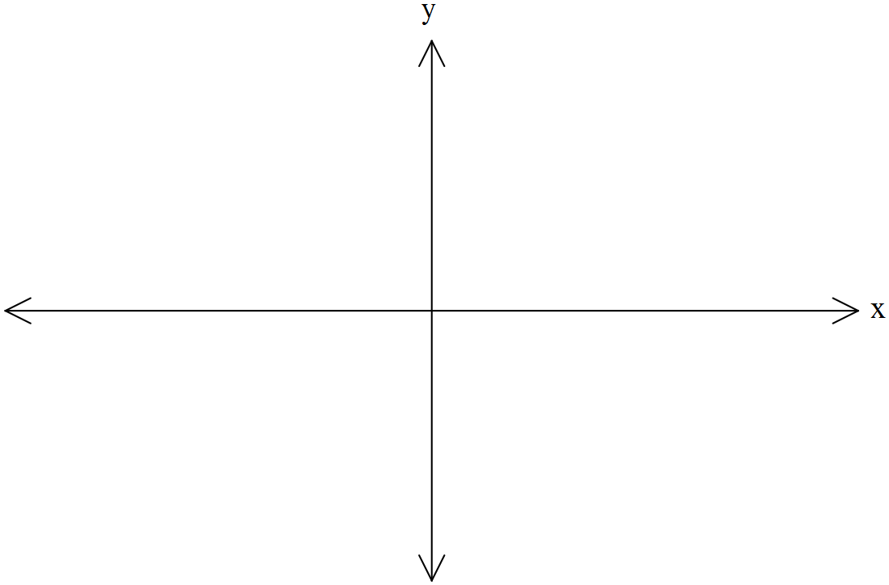

8. [3 marks]

The grid below shows a graph of y = cos(x) from 0 to 3π.
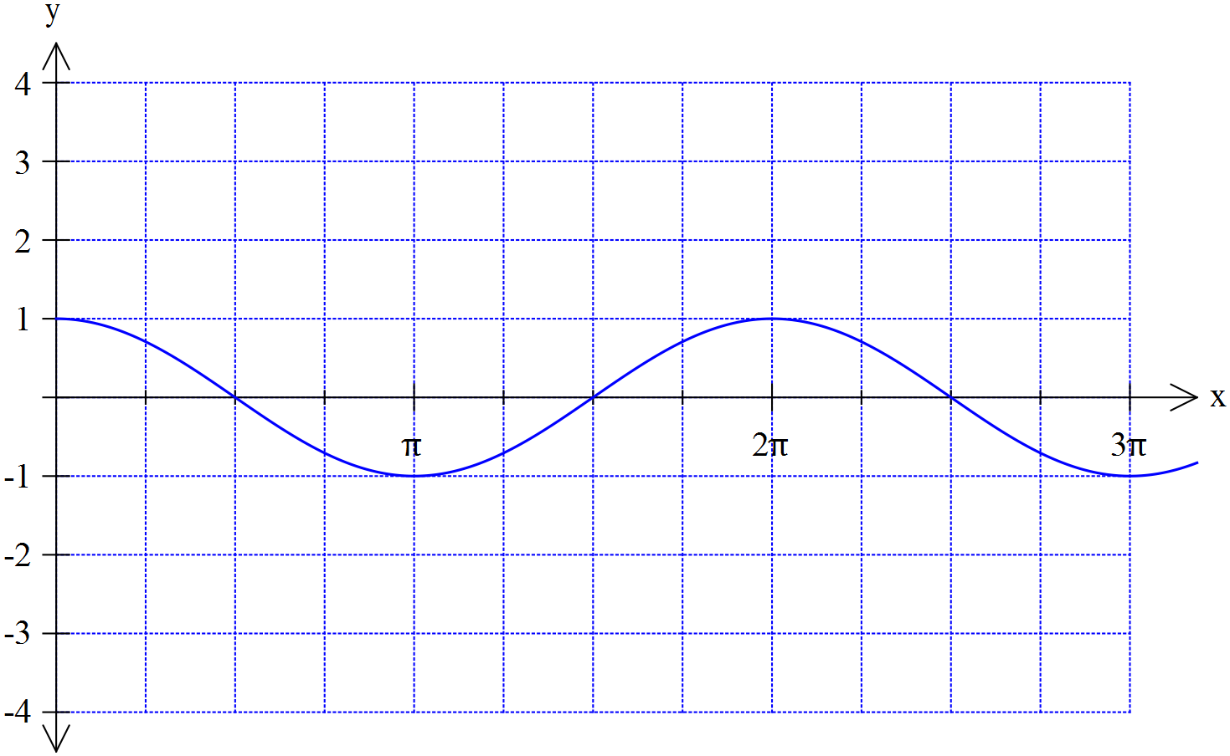

Plot the graph of y = -3 cos (2x) on the axes above

9. [4 marks]

Find all solutions to the equation cos (2x) = 0.5 for the domain 0 ≤ x ≤ 360º

Manjimup SHS 2015

Year 11 Mathematics Methods

Test 3

Quadratics, Functions, Transformations, Trigonometry

Name:

Score: out of

26

Calculator Section (Calculators and 1 page (A4) of notes permitted, formula sheet provided)

Time: 40 minutes Marks: 33 marks

10. [4 marks]

Determine the rules for these functions.
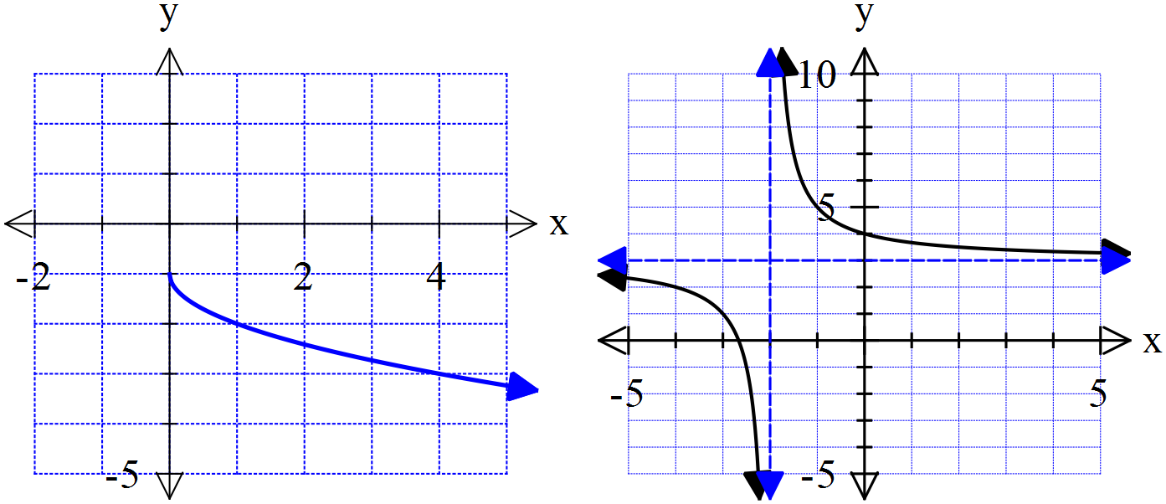

…………………………………

………………………………..

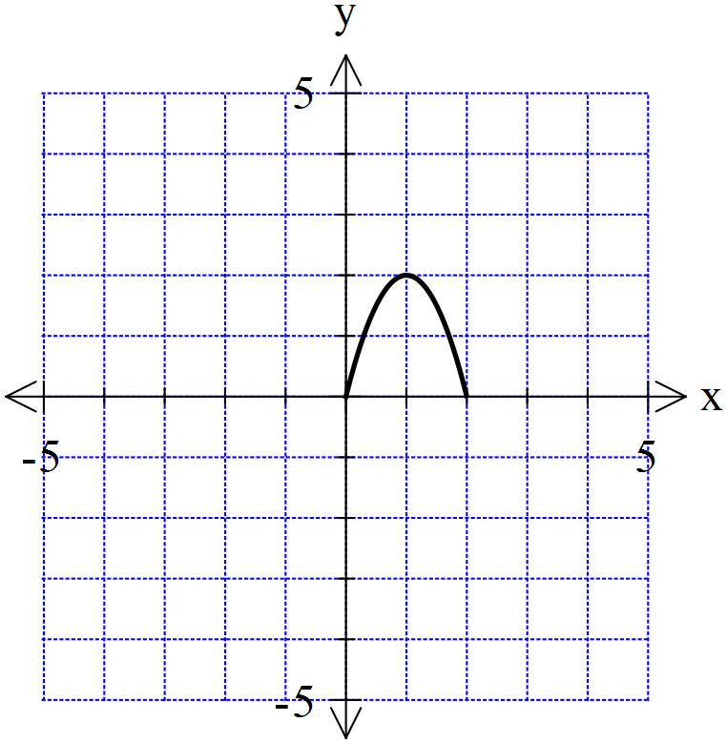
11. [2,3 = 4 marks]

Shown to the right is a graph of the function f(x).
Using your knowledge of transformations sketch
the following

- y = 2 f(x + 4) b) y = - f(-2x)
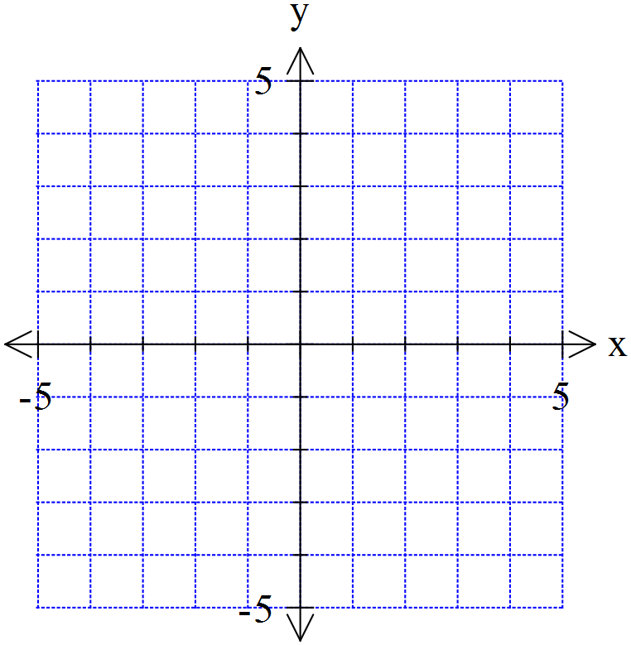


12. [2,3,2 = 7 marks]

a) State the rule for a circle with a radius of with a centre of (-2,1).

b) Write the rule in the form x² + y² + dx + ey = f

- Determine the distance from the closest point on the circle to the origin at (0,0)

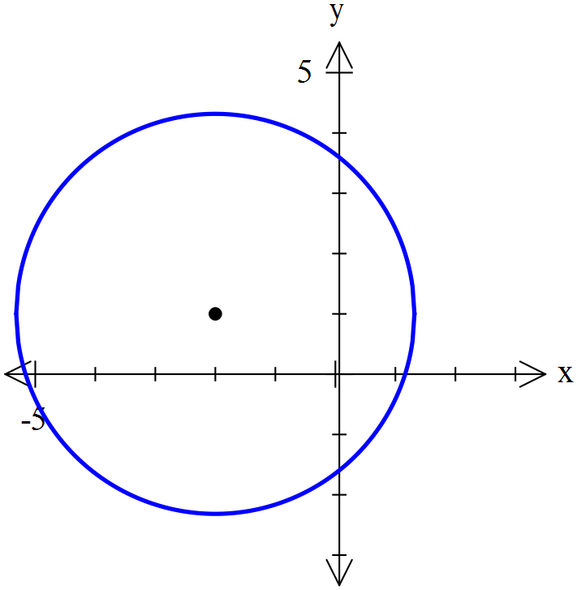

13. [1,4,1,2 = 8 marks]
The depth of water in a flask in a science experiment was measured for an eight hour period and followed the rule , where was the number of hours since the experiment began and the depth of water in centimetres.

- What was the depth of water when the experiment began?

Graph on your calculator. Use it to answer the following questions
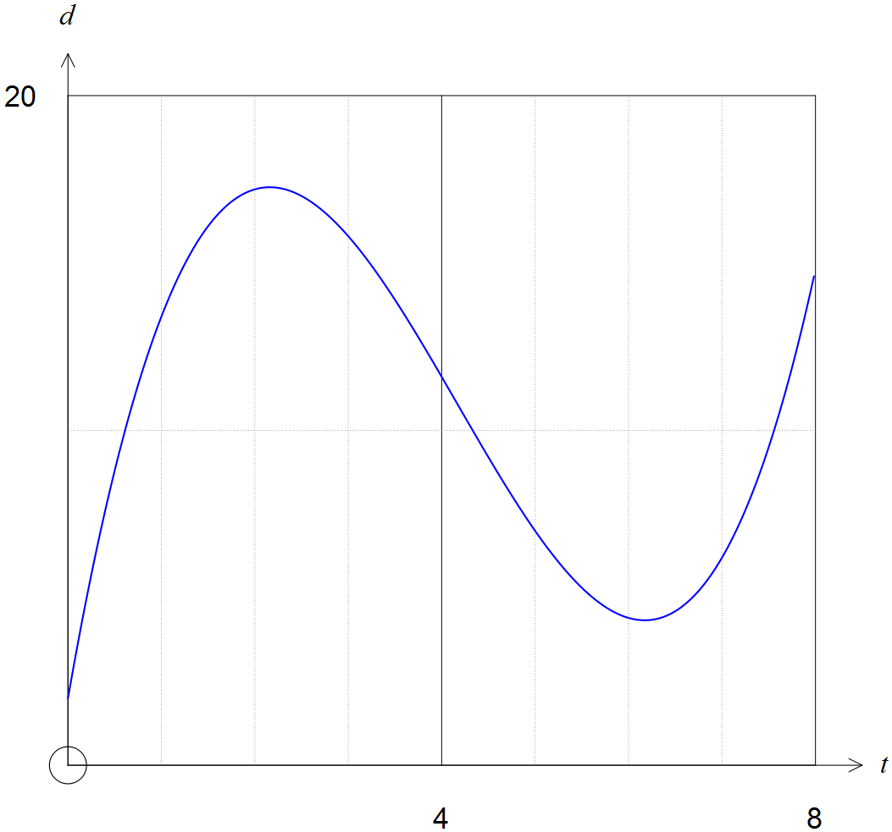

- In total for how many hours and minutes was the depth 10cm or more during the eight hour period?

- What was the minimum depth of water during the first eight hours?

- At what time, correct to nearest minute, was the depth a maximum during the first eight hours?

14. [3 marks]

Use the quadratic formula to solve 0 = 10x² – x – 2. Show all steps clearly.

